

**Company Profile**

Mulax Electronics (PTY) Ltd

2011/053569/23

**About us**

Mulax Electronics (Pty) Ltd. was founded in 2008. We believe that there is a need for security and safety in Residential, Business locations, Government Institutes and Retail Shops.

With increasing rate of crime over South Africa, it is very critical to have safe and reliable security system in your organisation. It is even more important to have security systems than cannot easily be tempered with and can be accessible and monitored remotely at any location, at any time in the globe. Mulax Electronics offers the best security services to meet the needs of your organisation. We are accredited installers for the highest quality, tested and reliable products from the best national and international security systems suppliers. We have selected brands with a technology that allows our clients to monitor their sites from smart phones, tablets and TV at a remote location.

We offer high quality security services/products from well-known brands at competitive prices. Our confidence in the products we utilize allows us to give our clients 2 year warranty, and free maintenance and service for a year.

**Vision Statement**

Mulax Electronics (Pty) Ltd. aims to become a leader in the electronic security industry around the Gauteng Province and nation at large.

**Mission Statement**

It is our mission at Mulax Electronics (Pty) Ltd. to offer innovative and approved electronic security systems for residential and business locations, government institutes and shops.

**Our Motto**

Technology for Innovators

**Services**

Our range of service includes ***Design, Installation and Repair*** of:

➢ Advanced CCTV and IP cameras Systems

➢ Alarm Systems

➢ Queue Management Systems

➢ Intercom System

➢ Access Control Systems

➢ Time attendance Systems

➢ Gate and Gaurage Motors

➢ Data Cabling

Mulax Electronics offers state-of-the-art security systems services to a vast range of industries, including:

* Retail
* Restaurants
* Residential
* Banks
* Government departments
* Education
* Healthcare
* Auto and garages
* Constriction Sites

We work hand in hand with our clients to deliver a solution according to their specification and requirements. We also offer a friendly training to our clients after installation.

Mulax Electronics aims to establish lasting reliable and valued relationship with its clients.

**Current and previous clients**

Some of our reference works are:

|  |  |
| --- | --- |
| **Customer Name** | **Services** |
| International Organization for Migration (IOM) offices (Hatfield, Pretoria) | * IP Cameras * Access Control * Network infrastructure and Supply of ICT Equipment |
| Taste of Africa Restaurant (Sunnyside, Pretoria) | * CCTV * Time attendance * DSTV |
| Taste of Africa Restaurant (Centurion, Pretoria) | * CCTV |
| Taste of Africa Restaurant (Fourways, Johannesburg) | * CCTV * Biometric System |
| Fruit and Veg (Sunnyside, Pretoria) | * CCTV and Alarm |
| Cell shop (Sunnyside, Pretoria) | * CCTV and Alarm |
| Sasol Garage Patrol Station (Sunnyside, Pretoria) | * IP cameras and Time attendance |
| Shell Garage (Thohoyandou, Limpopo) | * CCTV |
| EDISON Renal & Dialysis Centre (Hammanskraal) | * CCTV and Data Cabling |
| EDISON Tire Centre (Makhado Limpopo) | * CCTV and Data Cabling |
| South African Department of Water Affairs | | * Access Control |

**Mulax** **Electronics Technicians**

Mulax Electronics is an accredited installer of many brands with many years of experience in the electronic security systems industry. We have hired highly qualified technicians to perform our quality installations, with the goal to surpass our customers’ expectations.

**Work Gallery**

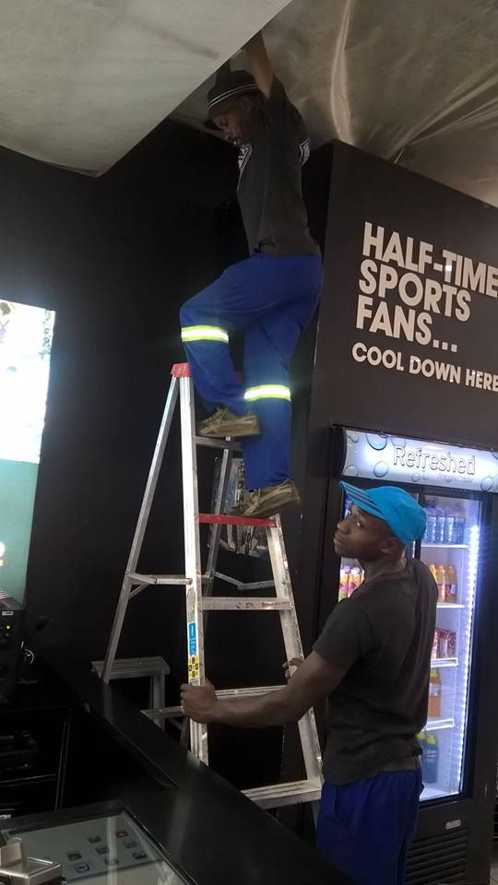 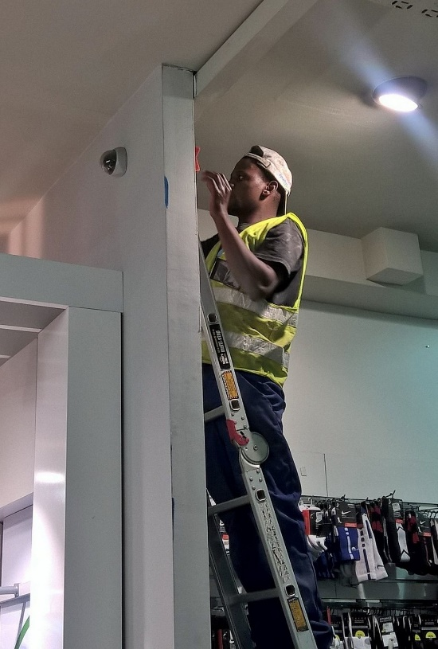 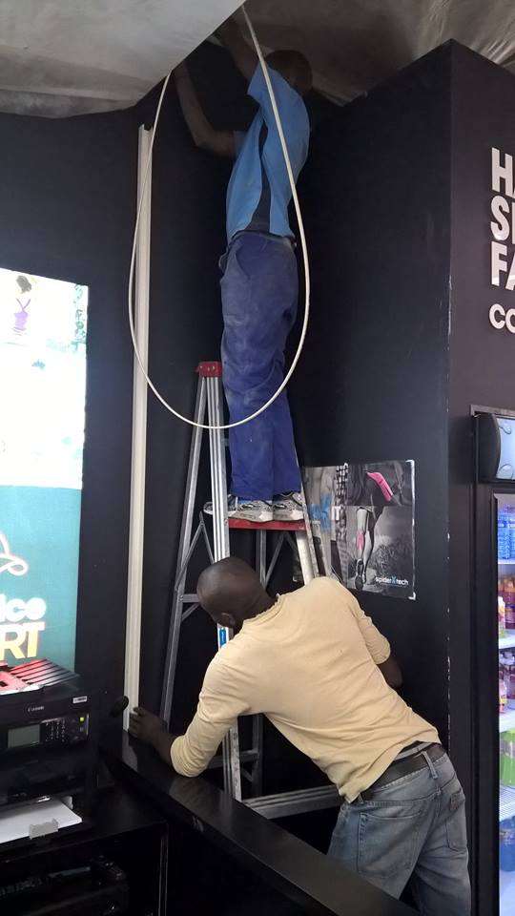

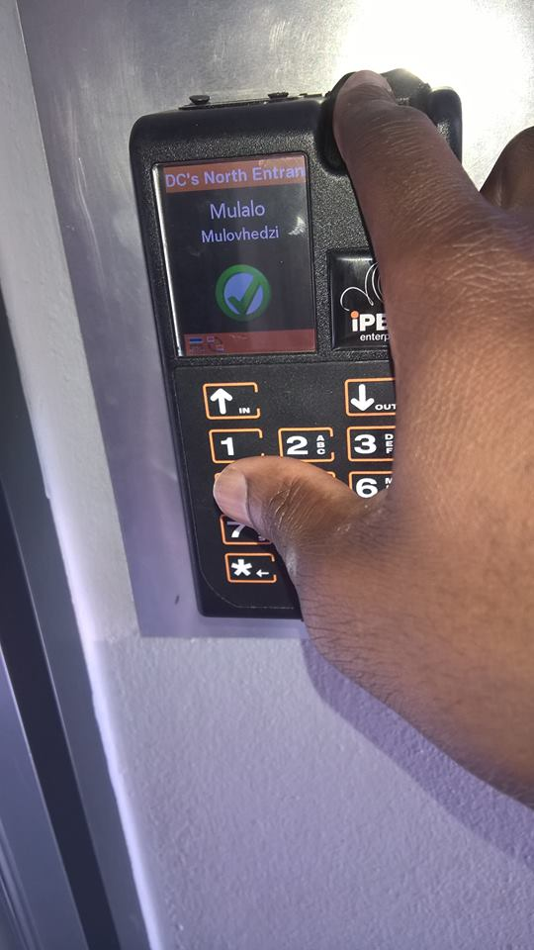 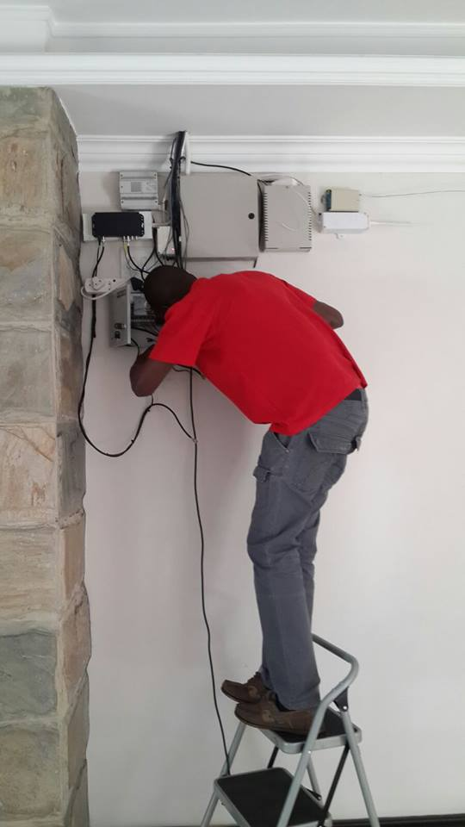 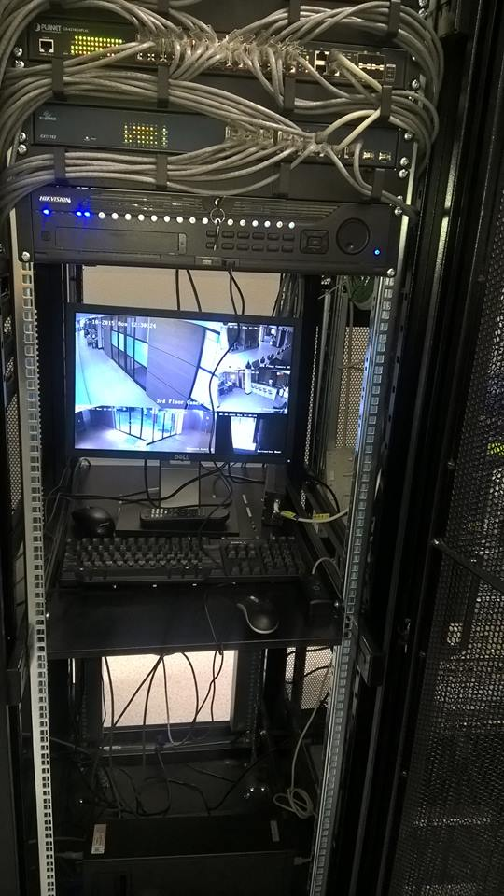

**Brands that we use for our services**

***Analog CCTV and IP Cameras***

** **

** **



***Biometric, Time and attendance Systems***

***  ***

***Access control and Intrusion Detection System***

***  ***

***  ***

**Company Details**

Business Name: Mulax Electronics (Pty) Ltd

Company Registration Number: 2011/053569/23

Tax Reference Number: 9329313176

Shareholders: 100% B-BBEE

**Contact Details**

Contact number: 012 755 0137 / 078 179 3322

Fax: 086 553 3284

Email: [info@mulax.co.za](mailto:info@mulax.co.za)

Physical Address: 07 Villa Ellardas

855 Barnad Street

Ellardus Park , Pretoria

Postal Address: P.O.Box 11748

Tramshed

Pretoria

0126